Meet Your Meats
Authors: Miranda McGuire & Yufei Guo
Unit Overview
Target Audience: 6 - 12th grade (after school program) | Est. Time: five 45 minute periods | Content Area(s): Animal & Meat Science (Fresh Meat Quality & Cookery)
Abstract:
The purpose of this unit is for participants to gain understanding and knowledge through STEM-related activities by informing participants what the aspects of meat quality are and how they can marinate their meat for better flavor and palatability by using a multidisciplinary learning approach. There are five lessons. The first unit starts with “where your meat comes from and what is meat color?” where participants will learn why meat changes color and what that means from a meat quality perspective. In the next lesson, they will learn USDA beef quality grades and what water holding capacity has to do with color and juiciness. The third lesson is about cut selection and safe handling of meat products. Participants will gain knowledge on the variations in meat tenderness based on the muscle location on the carcass and commonly missed places during hand washing. The fourth lesson is about technologies used to improve the tenderness and function of different types of marinades. Participants will learn how to use the engineering design process and simulate the process by determining what marinade is best for various meat cuts provided and creating their own marinade accordingly. The last lesson is about end cooking temperatures and cooking methods best suited for different cuts. In this lesson, participants will learn why and how to use a cooking thermometer for their safety and eating experience. They will also get to see how their meat tastes from the marinade they created. This unit integrates standards from the Indiana Department of Education in technology, engineering, mathematics, and science through an experiential learning method. This lesson is designed to promote knowledge of fresh red meat quality and different cookeries to the younger generation to increase meat palatability and food safety for more families.
Unit Goals/Objectives:
Students will be able to….
- Select and prepare quality cuts of meat based on flavor and palatability criteria and safety standards
- Identify different cuts of pork and beef
- Explain where meat comes from
Lesson Summaries:
Lesson 1: Where Meat Comes From and Introduction of Meat Color
- Students will be able to differentiate the colors and states of Myoglobin.
- Students will be able to identify the desirability of meat color to consumers.
- Students will be able to compose a decision based on meat color when selecting meat to cook with.
Lesson 2: Water Holding Capacity + Marbling
- Students will be able to describe how pH affects the juiciness of meat.
- Students will be able to identify degrees of marbling on different cuts of meat.
- Students will be able to recognize USDA quality grades in beef.
Lesson 3: Overall Cut Selection
- Students will be able to recognize cuts of meat on beef and pig carcasses.
- Students will be able to interpret what part of the animal their food comes from.
- Students will be able to select a piece of meat in a retail setting and justify the purchase decision based on scientific reasoning.
Lesson 4: Tenderizations and Marinades
- Students will be able to identify different ways to tenderize meat.
- Students will be able to create the best type of marinade for different cuts of meat.
- Students will be able to describe the role of ingredients used in marinades
Lesson 5: Raw Meat Handling & Safe Cooking Temperatures
- Students will be able to determine the cooking temperature for various meats (degree of doneness).
- Students will be able to identify any improper use of cookwares when preparing raw meat, vegetables and cooked products.
- Students will be able to demonstrate how to handle raw meat correctly.
Lesson Timeline:
Lesson 1: Where Meat Comes From and Introduction of Meat Color
- Interest Approach (5 minutes)
- Color Change Activity (25 minutes)
- Color Change Game (10 minutes)
- Formative Assessment (5 minutes)
Lesson 2: Water Holding Capacity + Marbling
- Interest Approach (2 minutes)
- pH, Isoelectric point, & Juiciness Activity (8 minutes)
- Meat Cuts, Grading, & Marbling (25 minutes)
- Taste Test & Formative Assessment (10 minutes)
Lesson 3: Overall Cut Selection
- Interest Approach (5 minutes)
- Pork Wholesale Cuts (10 minutes)
- Beef Wholesale Cuts (10 minutes)
- Cookout Case Study & Formative Assessment (20 minutes)
Lesson 4: Tenderizations and Marinades
- Interest Approach (10 minutes)
- Tenderization & Marinades (10 minutes)
- Case Study & Formative Assessment (25 minutes)
Lesson 5: Raw Meat Handling & Safe Cooking Temperatures
- Review (5 minutes)
- Interest Appraoch (10 minutes)
- Safe Cooking Temperatures (15 minutes)
- Internal Cooking Temperature Activity (5 minutes)
- Summative Assessment (10 minutes)
Standards:
Indiana Department of Education Standards: or NGSS (the national standard)
Engineering and Technology – Middle Level
- Core Standard 1: Students will examine how engineering and technology helps improve, manage, and control natural and engineered environments.
  - ETE – 1.4: Demonstrate safe practices and procedures with tools and equipment.
    - Core Standard 4: Students will apply engineering principles when planning, developing, implementing, and analyzing technological solutions.
- ETE – 4.1: Apply the steps of the design process.
- ETE – 4.2: Use the design process to create a product that addresses a real-world problem.
- ETE – 4.3: Create a technical sketch of a design with appropriate annotation.
- ETE – 4.4: Develop a product using the design process while maintaining appropriate documentation.
- ETE – 4.5: Develop various types of models (graphical, physical, or mathematical) that help communicate solutions to peers.
- Core Standard 7: Students will select, use, create, and evaluate construction technologies.
  - ETE – 7. 3: Construct simulations, models, and/or structures for specific construction systems.
Mathematics
- 4.NS.1: Read and write whole numbers up to 1,000,000. Use words, models, standard form, and expanded form to represent and show equivalent forms of whole numbers up to 1,000,000.
- 4.C.1: Add and subtract multi-digit whole numbers fluently using a standard algorithmic approach.
- 4.G.1: Identify, describe, and draw parallelograms, rhombuses, and trapezoids using appropriate tools (e.g., ruler, straightedge, and technology).
- 4.G.3: Recognize angles as geometric shapes that are formed wherever two rays share a common endpoint.
- 5.NS.2: Explain different interpretations of fractions, including: as parts of a whole, parts of a set, and division of whole numbers by whole numbers.
Science
- 3-5.E.3 Construct and perform fair investigations in which variables are controlled, and failure points are considered to identify aspects of a model or prototype that can be improved.
- 6-8.E.2 Evaluate competing design solutions using a systematic process to identify how well they meet the criteria and constraints of the problem.
- 6-8.E.3 Analyze data from investigations to determine similarities and differences among several design solutions to identify the best characteristics of each that can be combined into a new solution to better meet the criteria for success.
STEM Integration within the Unit:
In the first lesson, science is the STEM component included here. This lesson does not have very high-level STEM integration; students need to have some foundation knowledge before they can use the information as tools for problem-solving. Inquiry-based teaching is used so students can draw from their prior knowledge. Lecture-demo instead of just lecture is used because the demonstration serves as a visual aid for students and potentially enhances learning. Lesson 2 is still in the “setting foundation stage” like lesson 1 but it has a slightly higher level of STEM integration. Mathematics and Science are the STEM components covered. The lesson focused on multiple disciplines in STEM and the activities built into the lesson required students to initiate entry-level critical thinking. This lesson is still building up to evidence-based reasoning. Material covered in lesson 1 and 2 should act like building blocks for students to use when we ask them to build a house – put everything together to solve problems – in lesson 3 and 4. Lessons 3 and 4 have more advanced STEM integration. An extended case study is used in both lessons. Lesson 3 includes Mathematics and lesson 4 has Technology and Engineering as STEM components with Science being the knowledge students can apply to the case study. Lesson 3 introduces heavy mathematics in the format of product pricing and budgeting. The case study provides a real-world scenario: students are given a budget to plan a cookout. They need to choose the most tender products within their budget. And to make the case study more in-depth, discount prices can be added. The discount can be based on meat color, appearances, and other meat quality aspects discussed in lessons 1 and 2 as foundation knowledge. A continued case study is implemented in lesson 4and builds off what students accomplish in lesson 3.The case study requires students to solve a problem. To accomplish this, students need to have a good understanding of what they have learned in prior lessons and be able to apply them here to justify their decision. The entire case study requires students to reflect on what they have learned, draw knowledge across multiple disciplines, and how and why to apply certain knowledge in a problem-solving setting where they would also have to be able to reason their decisions based on evidence. While solving the problem, meat color, muscle location, etc. requires knowledge in science, budgeting and choosing the cut requires mathematics and science and deciding what kind of marinade – a technology used to tenderize meat and improve partiality— to make based on what cut they chose requires engineering design which pulls the STM together. The case study provides basic instructions, but it has a great open space for students to create their answers. Creative thinking can be seen when students are deciding what purchase – purchase a single kind of steak or a combination of steak that maximizes eating experience within budget and how students choose to utilize ingredients for their marinade. Critical and systematic thinking can be observed from students being able to articulate their solutions to the problems presented in the case study. Lesson 5 includes multiple STEM disciplines and requires students to have a good understanding of prior knowledge learned in the unit.

Lesson 1: Where Meat Comes From and Introduction of Meat Color
Est. Time: 45 minutes
Lesson Learning Goals/Objectives:
- Students will be able to differentiate the colors and states of Myoglobin.
- Students will be able to identify the desirability of meat color to consumers.
- Students will be able to compose a decision based on meat color when selecting meat to cook with.
Assessments
Formative:
Where Does My Meat Come From Student Assessment
Concept Prerequisites or Background Knowledge Needed:
Where does meat come from, knowledge of types of meat, oxidation
Vocabulary:
myoglobin, oxymyoglobin, deoxymyoglobin, oxidation
Materials & Technology Needed:
Coloring utensil colors: Brown, Purple, & Red
Cards with different states and colors of meat to assign students with (use images from Meat Colors)
Meat Colors (Attached below)
Student and Teacher Myoglobin Worksheets (attached below)
Where Does My Meat Come From Student Assessment & Key (attached below)
Lesson Component | Instructions |  | Materials
Introduction  5 minutes | Interest Approach  Start by asking students questions about meat:  - “Where does meat come from?”  - What types of meat are there?  - Why do we eat meat?  - Great source of Protein & Iron  Then, ask students about what meat looks like:  - “What does meat look like?”  - “Have you seen different colors of meat?”  - “If so, what colors have you seen?”  Tell students how in this lesson they will be learning what the different colors of meat means and how that relates to freshness. (Spoiler, color is not an indicator of freshness)  Show pictures of different fresh meat exhibiting various shades of color and pick which ones they think are “normal”. |  | Meat Colors pictures
Instructional Activities  35 minutes | What Causes Colors to Change? (25 minutes)  Why does meat color matter?  - Consumers associate meat color with the freshness of the product. But is that necessarily true?  Color is used by consumers to determine if meat is fresh and safe to eat.  - It is the single most important driving factor in a consumer’s decision to purchase meat.  Myoglobin is responsible for giving meat its color, and it is a great source of dietary iron.  Myoglobin stores oxygen in muscle cells.  - Example, myoglobin is like hemoglobin (which stores oxygen for blood cells) except for muscle cells.  Depending on how much exposure to oxygen Myoglobin has, this is what causes Myoglobin to have 3 natural colors and why meat changes colors.  There are also other factors that impact how much Myoglobin is in meat. (discuss briefly)  - There is more Myoglobin in beef and poultry (red meat vs white meat).  - Lamb and pork have intermediate amounts.  - Age of an animal, with older animals having more myoglobin and darker meat.  - Muscles that are used for movement also have more myoglobin content than muscles used for support.  Ask students if they have ever seen the “liquid” or “meat juices” in meat packages or that leaks out when cooking.  - Most people think it is blood. But, it is actually Myoglobin and not blood because most of the blood is removed at the time of slaughter.  What does oxygen do to Myoglobin through the meat color change process?  - If no oxygen is present, the meat appears purple and is in the deoxymyoglobin state.  - For example, vacuum packaged meat.  - Meat is bright red when exposed to air and is in the oxymyoglobin state.  - For example, meat they see in the store.  - Meat is brown when it has been exposed to oxygen for longer amounts of time.  - Meat that has sat in the store for a little bit.  Finally, talk about how color doesn’t define the freshness of the meat, just the state of myoglobin! |  | Each student will need the following coloring utensil to color with:  -Brown  -Purple  -Red  Student copy of State of Myoglobin Worksheet  Teacher copy of State of Myoglobin Worksheet
 | Meat Color Change Game (10 minutes)  - Students are assigned either a color of myoglobin (red, purple, or brow) or a state of myoglobin (DeoxyMb, OxyMb, MetMb).  - Students then have to determine who their “match” is. |  | Cards with different states and colors to assign students with. (Use pictures from Color Handout)
Wrap Up,  Synthesis/Closure  5 minutes | Review the states of Myoglobin:  - What are the three states of myoglobin?  Review the colors of Myoglobin:  - What color is DeoxyMb?  - What color is OxyMb?  - What color is MetMb?  True or False: Color defines the freshness of meat. |  | Where Does My Meat Come From Student Assessment  Where Does My Meat Come From Assessment Key
Resources:

Lesson 2: Water Holding Capacity + Marbling
Est. Time: 45 minutes
Lesson Learning Goals/Objectives:
- Students will be able to describe how pH affects the juiciness of meat.
- Students will be able to identify degrees of marbling on different cuts of meat.
- Students will be able to recognize USDA quality grades in beef.
Assessments
Formative:
Discussions, Taste Test: Water Holding Capacity Student Assessment
Concept Prerequisites or Background Knowledge Needed:
understanding of pH
Vocabulary:
isoelectric, pH, water holding capacity, maturity, marbling, intramuscular, quality grade
Materials & Technology Needed:
PSE meat vs. normal pork chop picture
Different Foods pH Worksheet (attached below)
USDA Cards (Order information below)
IMF on rib-eye steak Powerpoint slides (attached below)
Cooked Choice Steak
Cooked Prime Steak
Cooked Wagyu Steak (Optional)
All steaks cooked to 155 F for internal temperature Water Holding Capacity Student Assessment
Water Holding Capacity Rubric and Key (attached below)

Lesson Component | Instructions |  | Materials
Introduction  2 minutes | Interest Approach  Start out by asking students questions about steak.  - How many of you enjoy a juicy steak off the grill? How many of you enjoy dry, crumbly steaks?  - The juiciness of your meat is impacted by water holding capacity, how well the meat proteins can hold onto water.
Instructional Activities  33 minutes | pH and Isoelectric point & Juiciness (8 minutes)  - The Isoelectric point of meat is around 5.0-5.2, it’s a bad thing in meat, and you want to stay far away from that. When the pH is near that point, water holding capacity drops drastically. So meat at lower pH holds less water and won’t be as juicy after cooking.  - For students to grasp pH, students will be given a list of foods to place on the pH scale where they think that food belongs.  - Increased water accumulation on the meat surface impacts light reflection and makes the meat look lighter in color  - Summary on slide: darker color → high pH → juicier  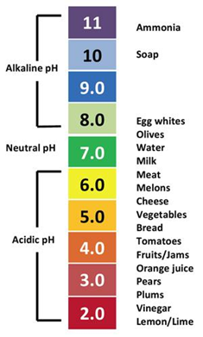 |  | Show PSE meat vs. normal pork chop picture  Different Foods pH Worksheet
 | USDA quality grade (Intramuscular fat), Identifying Types of Fat on Rib-eye Cuts Activity, & Amount of Marbling Activity (25 minutes)  Teach students what Marbling is:  - 3 types of animal fat, (so they can differentiate with cuts in a store.)  Introduce the USDA quality grades and how it’s determined in beef (Maturity & Marbling)  - Pork doesn't have USDA QG  Explain that’s what they see of quality grades (i.e., prime, choice, etc.) in stores  Why is more marbling better?  - IMF melts during cooking and acts as a lubricant during chewing, servers as a barrier to moisture loss  Fun fact: Prime rib  Identify different types of fat on ribeye steak/roast and compare variations in the amount of marbling among different muscle cuts. |  | USDA Cards  (Order information below)  Compare IMF on rib-eye steak slides
Wrap Up,  Synthesis/Closure  10 minutes | Taste Test (10 minutes)  Taste different grades of beef and see if students can taste the differences  Formative Assessment  - Students are given a rating scale during the activity.  - Students have to rate the palatability of each meat cut they experience during the taste test and write reasons explaining their reasonings |  | Taste Test: Cooked Select Steak  Cooked Choice Steak  Cooked Prime Steak  Cooked Wagyu Steak (Optional)  All steaks cooked to 155 F for internal temperature Water Holding Capacity Student Assessment  Water Holding Capacity Rubric and Key
Resources:

Lesson 3: Overall Cut Selection
Est. Time: 45 minutes
Lesson Learning Goals/Objectives:
- Students will be able to recognize cuts of meat on beef and pig carcasses.
- Students will be able to interpret what part of the animal their food comes from.
- Students will be able to select a piece of meat in a retail setting and justify the purchase decision based on scientific reasoning.
Assessments
Formative:
Overall Cut Selection Assessment
Concept Prerequisites or Background Knowledge Needed:
Wholesale vs retail cuts,, budgeting, Lesson 1-2 content

Vocabulary:
Wholesale, retail, locomotive muscle, supportive muscle
Materials & Technology Needed:
Diagram of wholesale cuts pork Swine Discovery - Wholesale Cuts | Animal & Food Sciences (uky.edu)
Diagram of wholesale cuts beef
https://afs.ca.uky.edu/livestock/test/beef/wholesale
Sensory panel information (with explanation which cuts are more tender); Data from Texas A&M (https://meat.tamu.edu/ansc-307-honors/meat-tenderness/)
Laminated pictures of retail cuts in a store so students can “shop” and “purchase” their meat for the cookout. (Pick own retail cuts and current prices based on the market.)
Play money so students can buy their meat.
Overall Cut Selection Assessment (attached below)
Lesson Component | Instructions |  | Materials
Introduction  5 minutes | Interest Approach  - Ask students what their favorite kind of meat dish is?
Instructional Activities  40 minutes | Different wholesales cuts of pork (10 minutes)  - Show picture of pork wholesale cuts  - Sides  - Pork carcass is split down the medial line |  | Diagram of wholesale cuts pork Swine Discovery - Wholesale Cuts | Animal & Food Sciences (uky.edu)
 | Different wholesales cuts of beef & Explain the location of muscle and tenderness (10 minutes)  Show picture of beef wholesale cuts  - Sides  - The beef carcass is split down the medial line  - Quarter  - Cut between the 12th and 13th rib of each side  - Explain forequarters and hindquarters in beef with the diagram  Explain which cuts are more tender  - Animals fatten from front to end and top to bottom  - Locomotive muscle vs. supportive muscle |  | Diagram of wholesale cuts beef  https://afs.ca.uky.edu/livestock/test/beef/wholesale  Sensory panel information (with explanation which cuts are more tender)  - Data from Texas A&M (https://meat.tamu.edu/ansc-307-honors/meat-tenderness/)
 | Cookout Case Study (20 minutes)  Students are divided into 3 groups, and each group is given a budget  - Group 1 has $10  - Group 2 has $20  - Group 3 has $30  On average, each person consumes around 6oz of meat per serving, and students need to provide for a family cookout of 4 people. Students need to buy the cut with the best eating experience within their budget  - Students are given  - Top round steak (5.99/lbs)  - *about 1.5lbs per packaging*  - Brown color, discounted, 4.99/lb  - Ribeye steak (13.99/lbs)  - *about 1-2 lbs per packaging*  - Brown color, discounted, 12.99/lbs  - Tenderloin (19.99/lbs)  - *about 0.6-0.7lbs per packaging*  - Brown color, discounted, 18.99/lb |  | -Laminated pictures of retail cuts in a store so students can “shop” and “purchase” their meat for the cookout.  (Pick your own retail cuts and current prices based on the market.)  -Cashier/Checkout Station to see if students stay on budget.  -Play money so students can buy their meat.  -Since the brown color is not appealing to consumers although it does not indicate the meat is not safe (information from meat color lesson), there’s a discount on those products. (Optional)
Wrap Up,  Synthesis/Closure  Time | Formative Assessment (incorporated in the activity)  Evidence-Based Reasoning  - Students explain the decisions they made for their best eating experience - based on sensory information provided (Texas A&M data) and previous material covered. |  | Student: Overall Cut Selection Assessment  Overall Cut Selection Key & Rubric
Resources:

Lesson 4: Tenderizations and Marinades
Est. Time: 45 minutes
Lesson Learning Goals/Objectives:
- Students will be able to identify different ways to tenderize meat.
- Students will be able to create the best type of marinade for different cuts of meat.
- Students will be able to describe the role of ingredients used in marinades.
Assessments
Formative:
Discussions, Tenderizations and Marinades Assessment
Concept Prerequisites or Background Knowledge Needed:
pH, Lesson 1-3 content, the five senses
Vocabulary:
Tenderizations, marinades, brine, enzymes
Materials & Technology Needed:
Powerpoint slides with picture examples of different kinds of spices, ingredients for the marinade
Case study Worksheet (attached below)
pencils
Tenderizations and Marinades Assessment (attached below)
Lesson Component | Instructions |  | Materials
Introduction  10 minutes | Interest Approach (10 minutes)  - Recap on how to select fresh meat cuts and safety of handling raw/cooked meat  - Move to ways to improve meat tenderness  Discussion:  - Ask students: they are presented with a piece of beef steak, how would they tenderize it?  - Students can draw from their past experiences/knowledge.
Instructional Activities  35 minutes | Methods of Tenderization (Mechanical, Brine, & Ingredients) & Types of Marinades (Dairy-based, Acid-based, & Tropical Based) (10 minutes)  Discussion:  - Recap discussion, and discuss common ways to improve tenderness.  - Briefly touch on mechanical and brine and how ingredients are used to build the marinade.  - We add ingredients to improve flavors, but some ingredients have other functions aside from that.  - Ingredients:  - Salt - bind water  - Water- disperse ingredients  - Sweeteners - counteract the harshness of salt  - Seasonings - give products identity  - Marinade:  - Incorporate the ingredients  - Something to soak for quite some time (sauces like BBQ that you add near the end of cooking is not marinade)  - Least to most tenderizing:  - Dairy-based - yogurt, buttermilk, cream  - Acid-based - vinegar, lime, lemon  - Tropical based - Tropical fruits, natural enzymes break down protein |  | Powerpoint slides with picture examples of different kinds of spices, ingredients for the marinade
 | Case study continue: Making the most suitable marinade for the meat they bought (25 minutes)  Students will decide what kind of marinade to use for the cut they picked within their budget.  Problem: Which kind of marinade-base should be used for each cut of meat to best improve tenderness?  Students have to draw knowledge from the prior lesson on cut selection to know the toughness of these cuts  - Top round steak: tough  - *Suggested Marinade: tropical-based*  - Ribeye steak: tender  - *Suggested Marinade: acid-based or dairy-based*  - Mostly focus on flavor  - Tenderloin steak: very tender  - *Suggested Marinade: don’t need much help on tenderness, can just focus on flavor* |  | Case study Worksheet  -What kind of marinade students choose to use and why (ex. Function, Flavor)
Wrap Up,  Synthesis/Closure  Time | Formative assessment (Incorporated in the activity)  Students need to provide some sensory comments between the marinade, taste, and their desired result.  Students also need to justify their decisions. |  | Student: Tenderizations and Marinades Assessment  Tenderizations and Marinades Key and Rubric
Resources:

Lesson 5: Raw Meat Handling & Safe Cooking Temperatures
Est. Time: 45 minutes
Lesson Learning Goals/Objectives:
- Students will be able to determine the cooking temperature for various meats (degree of doneness).
- Students will be able to identify any improper use of cookwares when preparing raw meat, vegetables and cooked products.
- Students will be able to demonstrate how to handle raw meat correctly
Assessments
Formative:
Discussions
Summative:
Unit summative assessment worksheet (attached below)
Concept Prerequisites or Background Knowledge Needed:
Lesson 1-4 content, bacteria
Vocabulary:
beef, poultry, internal temperature, foodborne illness
Materials & Technology Needed:
Mentimeter polling program (https://www.mentimeter.com/)
Information from FoodSafety.gov (Cook to a Safe Minimum Internal Temperature | FoodSafety.gov)
Pictures of different meat thermometers (pictures below)
Playdough
Meat thermometers
Summative assessment worksheet (attached below)
Summative assessment Rubric (attached below)
Lesson Component | Instructions |  | Materials
Introduction  5 minutes | Recap what students did in making marinade lesson  Give feedback on the marinade students chose in the previous lesson
Instructional Activities  Time | Interesting Approach: Handling Raw Meat  Give students scenarios and ask how they would handle the raw meat (True or False).  - I can prepare my vegetables and fruits using the same cutting board after I cut my raw steak.  - I can use the same cooking materials for my raw meat and veggies for salad.  - I can use the same cutting board I used to prepare the raw meat to cut up my cooked steak.  - After marinating the raw steak, I can use the same marinade as a sauce to drizzle over my cooked steaks.  - I can use the same cooking utensils for raw and cooked meat without washing them.  - After handling raw meat with my hands, I can touch the seasoning bottoms directly without washing my hands.  Good and poor Ways to handle raw meat.  - Types of cutting boards  - cuts vs ground beef vs poultry.  - If anything touched raw meat, treat it as raw meat |  | Mentimeter polling program
 | Safe cooking temperatures (15 minutes)  Talk about end cooking temperatures factors:  - Safety  - Quality  How to determine the meat is done?  - Ask students if they have heard these myths  - Cook until there’s no pink?  - Cook until the juices run clear?  - These are not reliable methods  Safe minimum cooking temperature for meat and why  - Why is internal temperature important  - Safety  - Undercooked, microorganisms and bacteria may be present and cause foodborne illness  - Quality  - Overcooked, tough, and dry product |  | Information from FoodSafety.gov (Cook to a Safe Minimum Internal Temperature | FoodSafety.gov)  Pictures of different meat thermometers (pictures below)
 | Internal Cooking Temperature Activity (5 minutes)  Demonstrate how to take the internal temperature properly with a meat thermometer  Recap: The best way to ensure safety and quality:  - Meat thermometer  - How to take the internal temperature |  | Playdough  Meat thermometers
Wrap Up,  Synthesis/Closure  10 minutes | Summative Assessment  Review Lessons 1-5 |  | Summative assessment worksheet  Rubric and key
Resources:

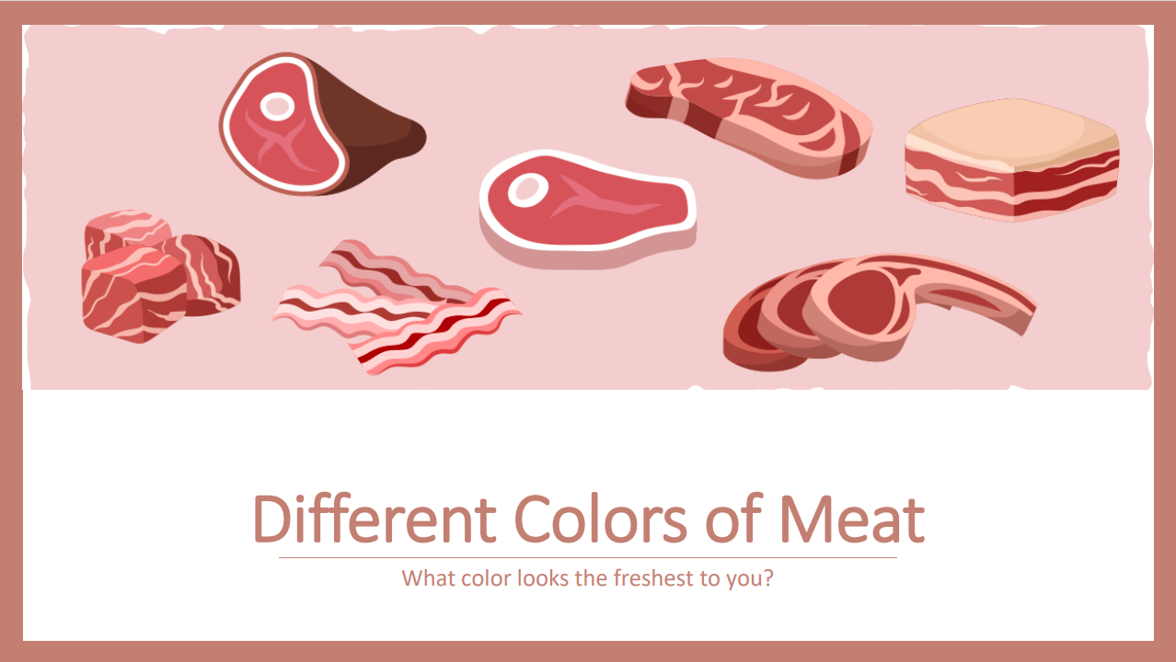

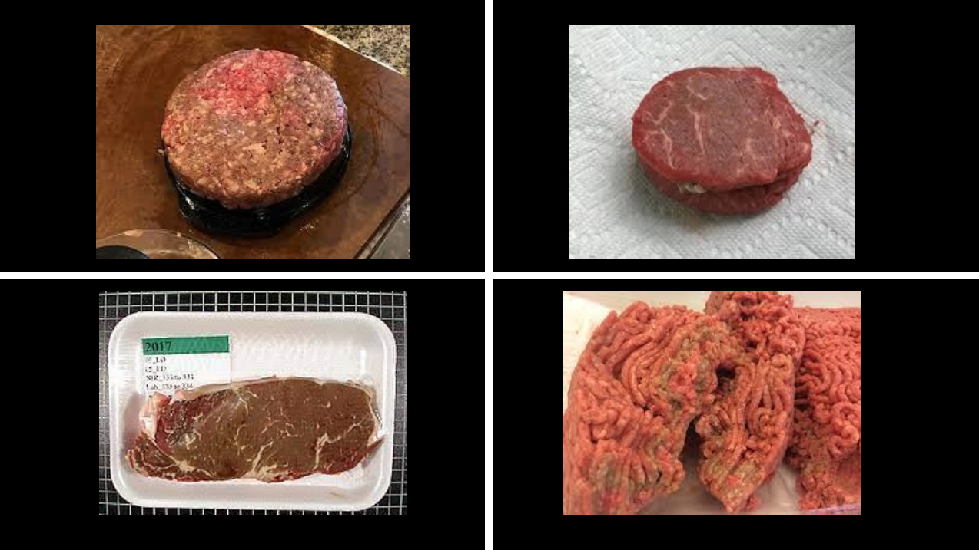

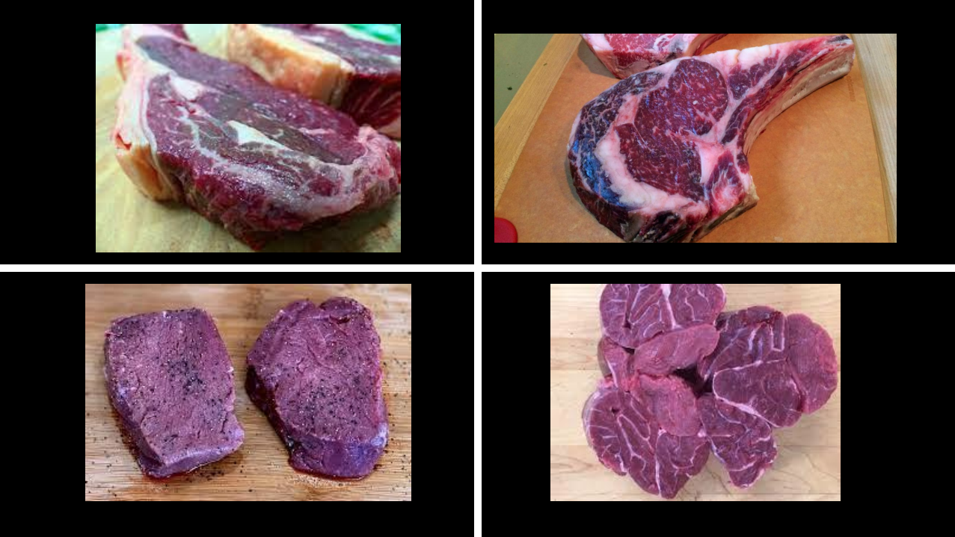

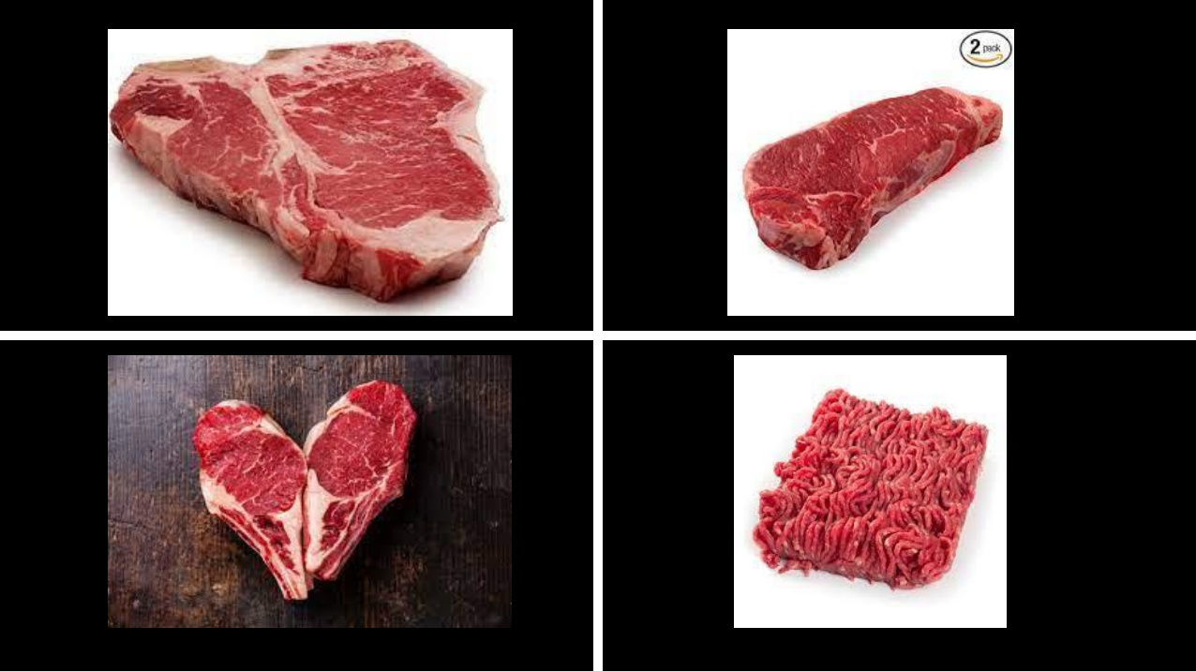
States of Myoglobin
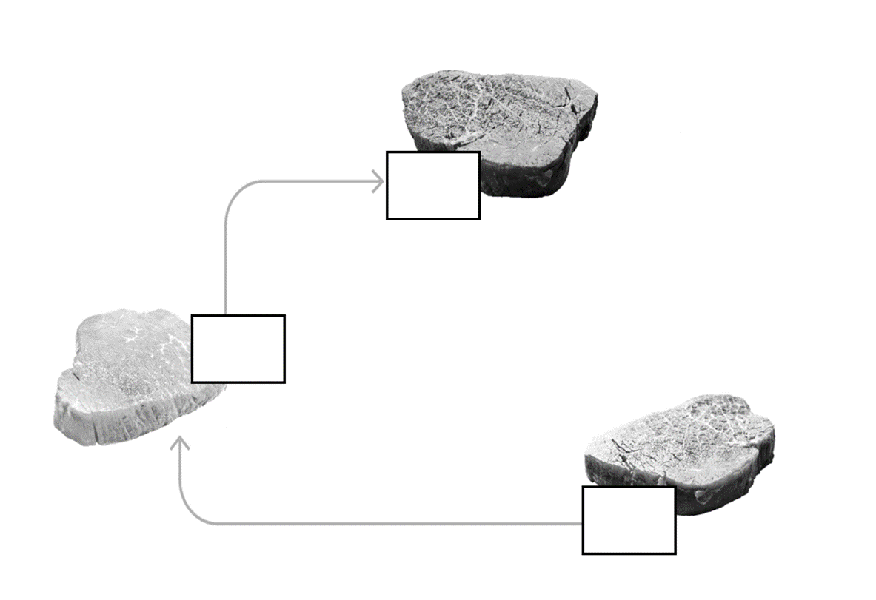
States of Myoglobin
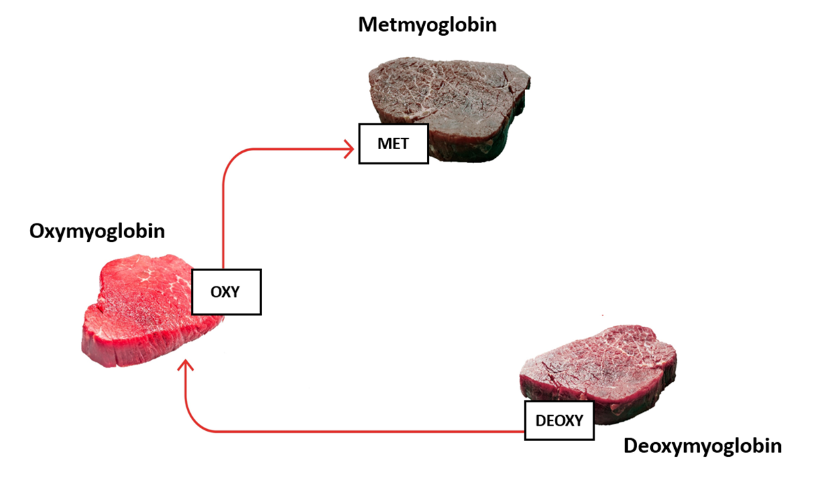

Where Meat Comes From and Introduction of Meat Color

Measuring Objectives:
- Students are able to differentiate the colors and states of Myoglobin.
- Students being able to identify the desirability of meat color to consumers.
- Students will be able to compose a decision based on meat color when selecting meat to cook with.

- What are the three states of myoglobin mentioned in the lesson?
________________________________________________________________________________________________________________________________________________________________________________________________________________________________________________________________________________________________________________________________________________________________________________________________________________________________________________________________________________________________________________________________________________________________________
- What color is DeoxyMb?
________________________________________________________________________________________________________________________________________________________________________________________
- What color is OxyMb?
________________________________________________________________________________________________________________________________________________________________________________________
- What color is MetMb?
________________________________________________________________________________________________________________________________________________________________________________________
- True or False: Color defines the freshness of meat.
_______________________________________________
- Which state of myoglobin is the most desired by consumers? Why?
________________________________________________________________________________________________________________________________________________________________________________________________________________________________________________________________________________________________________________________________________________________________________________________________________________________________________________________________________________________________________________________________________________________________________

Lesson 1: Where Meat Comes From and Introduction of Meat Color KEY

Measuring Objectives:
- Students are able to differentiate the colors and states of Myoglobin.
- Students being able to identify the desirability of meat color to consumers.
- Students will be able to compose a decision based on meat color when selecting meat to cook with.

- What are the three states of myoglobin mentioned in the lesson?
Deoxymyoglobin, Oxymyoglobin, Metmyoglobin

- What color is DeoxyMb?
Purple, dark red

- What color is OxyMb?
Bright red, cherry red

- What color is MetMb?
Brown

- True or False: Color defines the freshness of meat.
False

- Which state of myoglobin is the most desired by consumers? Why?
Oxymyoglobin is the most desired by consumers. Because the bright red color aligns with consumers’ perception of freshness even though color does not indicate freshness of the meat.

Different Foods Student pH Worksheet

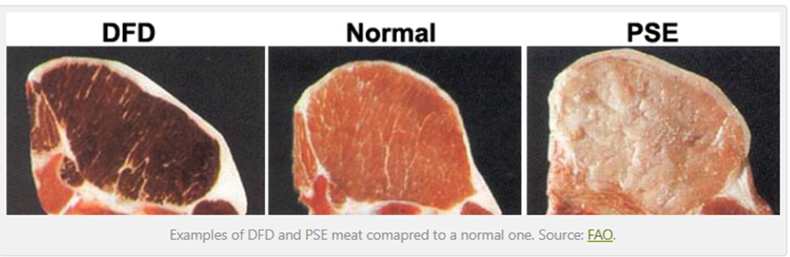

- Please record the pH of each pork chop.
____________________________________________________________________________________________________________________________________________________________________________________________________________________________________________________________
- Which pork chop looks the most desirable if you are to purchase one? Why?
____________________________________________________________________________________________________________________________________________________________________________________________________________________________________________________________
- Which pork chop has the highest pH?
________________________________________________________________________________________________________________________________________________________________________
- Which pork chop is the closest to the isoelectric point?
____________________________________________________________________________________________________________________________________________________________________________________________________________________________________________________________
- What characteristics would you anticipate seeing for pork chops with pH at the isoelectric point?
____________________________________________________________________________________________________________________________________________________________________________________________________________________________________________________________

Lesson 2 Slides
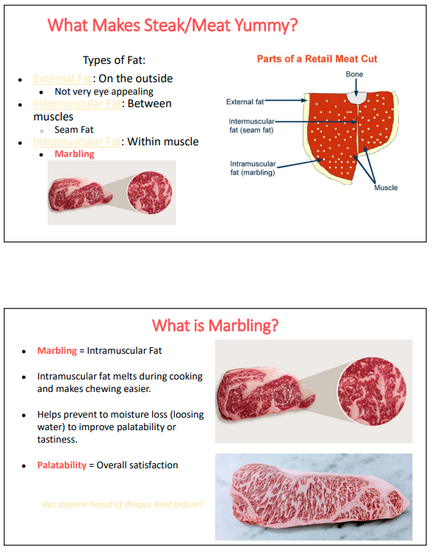
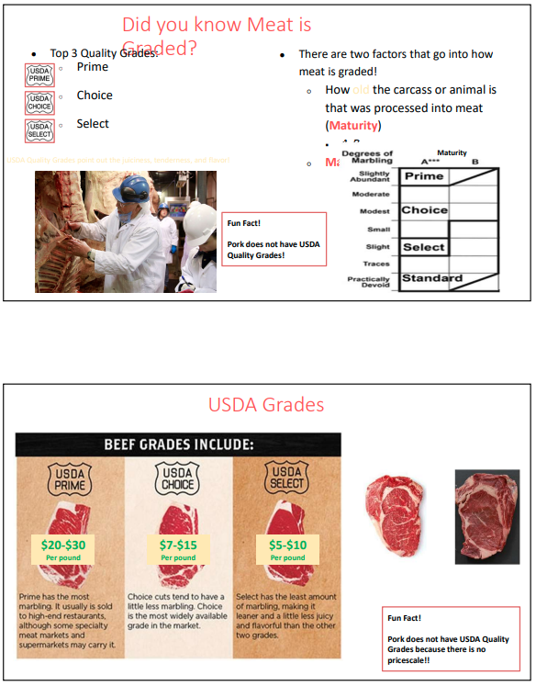
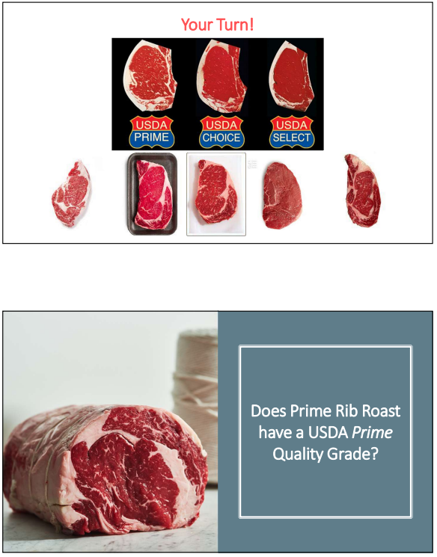
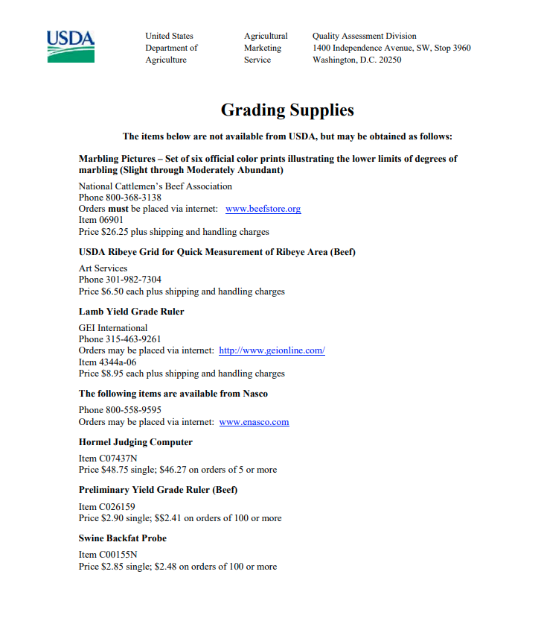

Lesson 2: Water Holding Capacity + Marbling (Activity Scale)
The assessment is designed to be used while students complete the taste test.
Measuring Objectives:
- Students are able to describe how pH affects the juiciness of meat.
- Students are able to identify degrees of marbling on different cuts of meat.
- Students are able to recognize USDA quality grades in beef.
- In your opinion, which steak has a higher pH and why?
_____________________________________________________________________
_____________________________________________________________________
_____________________________________________________________________
_____________________________________________________________________
_____________________________________________________________________
_____________________________________________________________________
- Describe any differences you observe between the different steaks.
_____________________________________________________________________
_____________________________________________________________________
_____________________________________________________________________
_____________________________________________________________________
_____________________________________________________________________
_____________________________________________________________________
- Please rate your eating experience for cooked select, choice, prime and wagyu steaks using the scale provided below:
- Please explain your ratings and include aspects of palatability, quality etc.
_____________________________________________________________________
_____________________________________________________________________
_____________________________________________________________________
_____________________________________________________________________
_____________________________________________________________________
_____________________________________________________________________

Rubric for Question 4 Lesson 2 Assessment

 | Insufficient Answer (Points: 0) | Sufficient Answer (Points: 5) | Excellent Answer (Points: 10)
Logic and completion | Student’s answers are not logical and show no evidence based reasoning. | Student’s answer follows a logical order but only covers one aspect. | Student’s answer is in logical order, and the answer includes reasoning and explanations on palatability, quality, marbling and juiciness.
Knowledge Retention | Students show no indication of any prior knowledge. | Students are able to regurgitate what they learned but can’t explain the knowledge well. | Student’s answer is straightforward and to the point. Students demonstrate they not only remember what they learned but also are able to explain the knowledge comfortably.
Application | Students show no understanding of prior material taught and cannot use the material to reason/solve problems. | Students show sufficient understanding of the material but fail to connect different aspects to piece the whole picture together. | Students show sufficient understanding of the information and are able to connect different aspects together to describe the whole picture and explain their reasonings clearly.
Overall:

KEY Lesson 2: Water Holding Capacity + Marbling (Activity Scale)
The assessment is designed to be used while students complete the taste test.

Measuring Objectives:
- Students are able to describe how pH affects the juiciness of meat.
- Students are able to identify degrees of marbling on different cuts of meat.
- Students are able to recognize USDA quality grades in beef.
- In your opinion, which steak has a higher pH and why?
Answer based students' reasoning. Key idea: darker color usually means higher pH

- Describe any differences you observe between the different steaks.
Key idea: differences in degree of marbling, and other aspects like color students might observe

- Please rate your eating experience for cooked select, choice, prime and wagyu steaks using the scale provided below:
- Please explain your ratings and include aspects of palatability, quality etc.
Key idea: students should address more marbling → better palatability, marbling impacts juiciness etc.

Lesson 3: Overall Cut Selection (Activity Rubric)
The assessment is designed to be used while students complete the Cookout Case Study activity.
Measuring Objectives:
- Students being able to recognize cuts of meat on beef and pig carcasses.
- Students are able to interpret what part of the animal their food comes from.
- Students are able to select a piece of meat in a retail setting and justify the purchase decision based on scientific reasoning.
- Please fill in the wholesale cuts of a pork carcass.
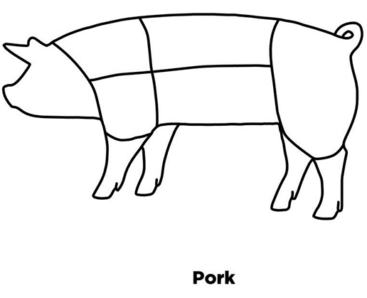
- Please list 3 beef wholesale cuts.
____________________________________________________________________________________________________________________________________________________________________________________________________________________________________________________________

- Please mark where the meat cuts used in the retail activity come from on the beef carcass.
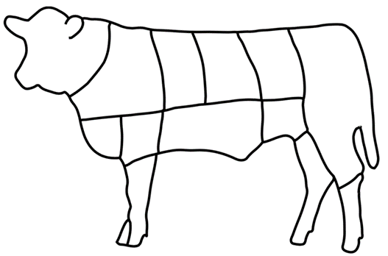
- Please explain your purchasing decisions and justify why you think that’s the best way to use your budget.
____________________________________________________________________________________________________________________________________________________________________________________________________________________________________________________________________________________________________________________________________________________________________________________________________________________________________________________________________________________________________________________________________________________________________________________________________________

Rubric for Question 4 in Lesson 3 Assessment
 | Insufficient Answer (Points: 0) | Sufficient Answer (Points: 5) | Excellent Answer (Points: 10)
Logic and completion | Student’s answers are not logical and show no evidence based reasoning. | Student’s answer follows a logical order but fails to explain how they reached their conclusion mathematically or why/why not they purchased discounted products. | Student’s answer is in logical order, and the answer includes reasoning and explanations on how they calculated their cost and budget, choice on purchasing any discounted products etc.
Knowledge Retention | Students show no indication of any prior knowledge. | Students are able to regurgitate what they learned but can’t explain the knowledge well. | Student’s answer is straightforward and to the point. Students demonstrate they not only remember what they learned but also are able to explain the knowledge comfortably.
Application | Students show no understanding of prior material taught and cannot use the material to reason/solve problems. | Students show sufficient understanding of the material but fail to connect different aspects to piece the whole picture together. | Students show sufficient understanding of the information and are able to connect different aspects together to describe the whole picture and explain their reasonings clearly.
Overall:

Lesson 4
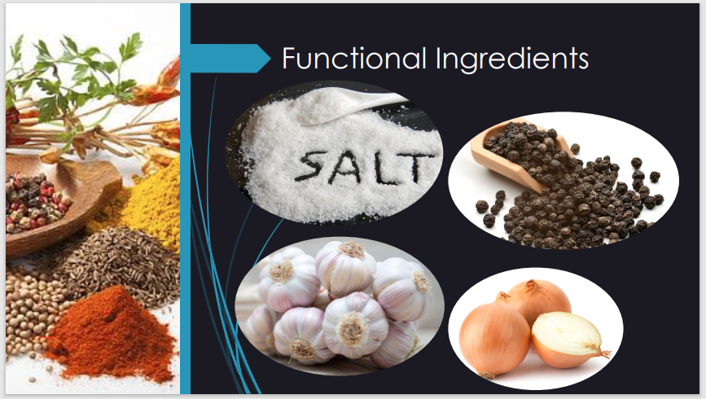
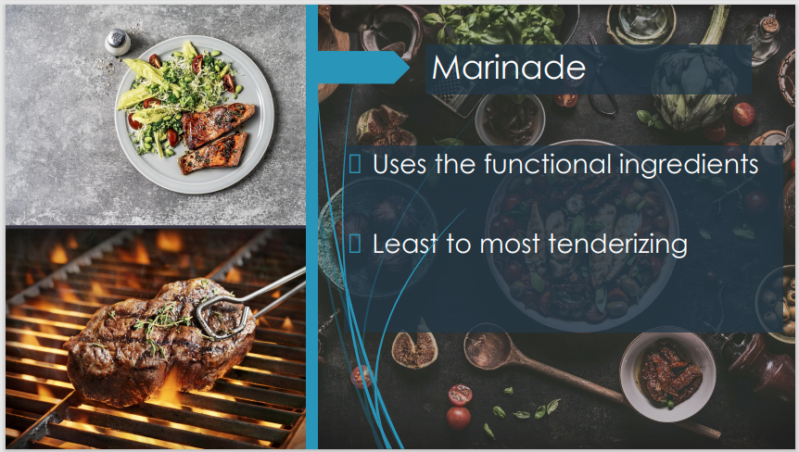
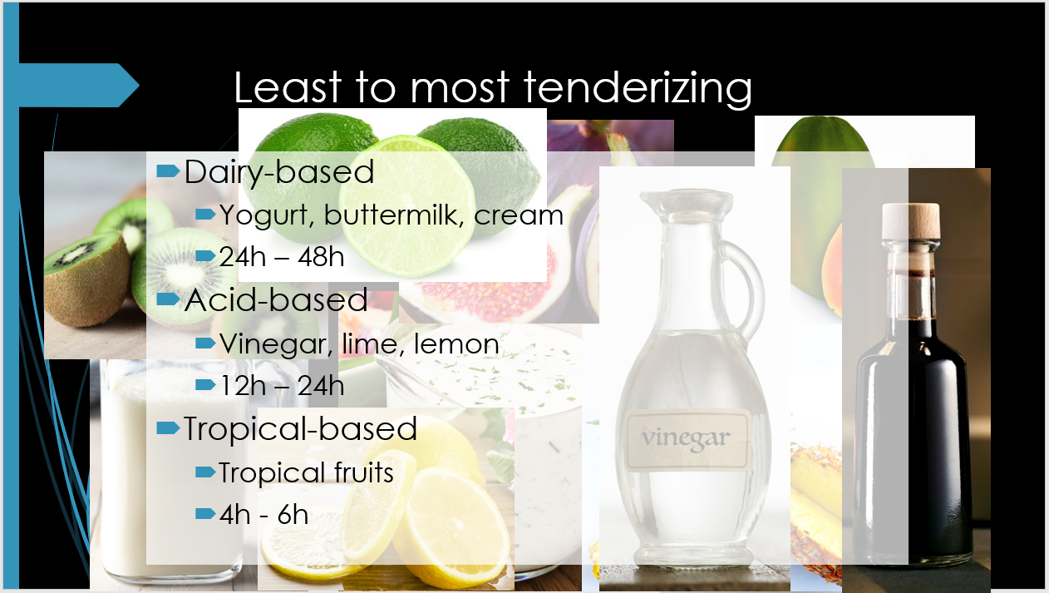

Lesson 4: Tenderizations and Marinades (Activity Rubric)
The assessment is designed to be used while students complete the Cookout Case Study Cont. activity.

Measuring Objectives:
- Students are able to identify different ways to tenderize meat.
- Students are able to create the best type of marinade for different cuts of meat.
- Students are able to describe the role of ingredients used in marinades.

- Please list the three different types of meat tenderization methods and explain how each method works.
_____________________________________________________________________
_____________________________________________________________________
_____________________________________________________________________
_____________________________________________________________________
_____________________________________________________________________
_____________________________________________________________________

- Please make a marinade for the cut of meat you bought in the cookout case study. And explain your thinking process which should include aspects why you chose this kind of marinade, reasons for choosing each ingredient etc. be as specific in your reasoning as possible.
_____________________________________________________________________
_____________________________________________________________________
_____________________________________________________________________
_____________________________________________________________________
_____________________________________________________________________
_____________________________________________________________________

KEY Lesson 4: Tenderizations and Marinades (Activity Rubric)
The assessment is designed to be used while students complete the Cookout Case Study Cont. activity.

Measuring Objectives:
- Students are able to identify different ways to tenderize meat.
- Students are able to create the best type of marinade for different cuts of meat.
- Students are able to describe the role of ingredients used in marinades.

- Please list the three different types of meat tenderization methods and explain how each method works.
Mechanical, salt water (brine enhancement), functional ingredients

- Please make a marinade for the cut of meat you bought in the cookout case study. And explain your thinking process which should include aspects why you chose this kind of marinade, reasons for choosing each ingredient etc. be as specific in your reasoning as possible.
Key idea: if they chose top round, they should use tropical based marinade because top round is tough (tie with marbling and locomotive muscle) and tropical has the most tenderizing effect. Ribeye and tenderloin are inherently tender cuts (tie with marbling and location of the muscle - supportive), so either dairy or acid based marinades would work.

Lesson 5 Meat Thermometers
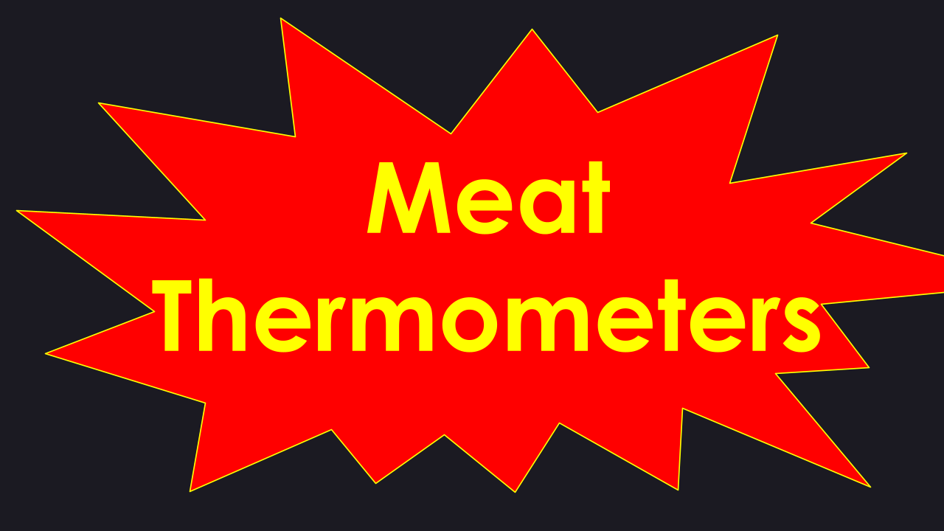
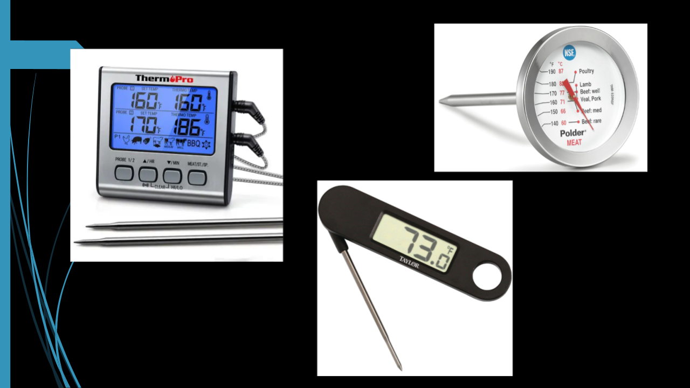
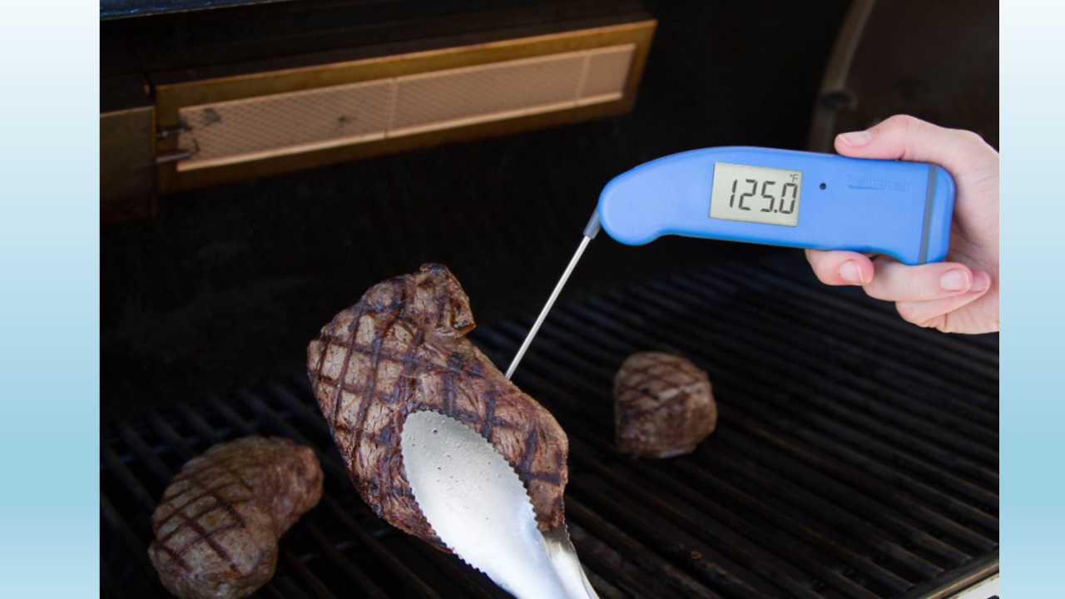

Lesson 5: Raw Meat Handling & Safe Cooking Temperatures (Post Unit Summative Assessment)
The assessment is designed to be used at the end of lesson 5 after students complete the mini-unit. The assessment should provide reflection on a student's knowledge retention and problem solving abilities using the information learned while facing real world problems.
Measuring Objectives:
- Students are able to identify the importance of internal cooking temperature.
- Students are able to justify meat related topics by drawing knowledge from all lessons covered in the unit.

- Why is meat color important?
________________________________________________________________________________________________________________________________________________________________________________________________________________________________________________________________________________________________________________________________________________________________________________
- What’s the relationship between color, pH, and juiciness?
________________________________________________________________________________________________________________________________________________________________________________________________________________________________________________________________________________________________________________________________________________________________________________
- Why was the top round steak tougher than the ribeye cut?
________________________________________________________________________________________________________________________________________________________________________________________________________________________________________________________________________________________________________________________________________________________________________________
- What is the importance of taking internal cooking temperatures?
________________________________________________________________________________________________________________________________________________________________________________________________________________________________________________________________________________________________________________________________________________________________________________

- You are asked to make 2 marinades: 1 for a top round steak and 1 for a ribeye steak. Please describe what kind of marinades you would choose and explain your thinking process which should include aspects why you chose this kind of marinade, reasons for choosing each ingredient etc. be as specific in your reasoning as possible.
________________________________________________________________________________________________________________________________________________________________________________________________________________________________________________________________________________________________________________________________________________________________________________

Lesson 5: Raw Meat Handling & Safe Cooking Temperatures (Post Unit Summative Assessment)
The assessment is designed to be used at the end of lesson 5 after students complete the mini-unit. The assessment should provide reflection on a student's knowledge retention and problem solving abilities using the information learned while facing real world problems.

Measuring Objectives:
- Students are able to identify the importance of internal cooking temperature.
- Students are able to justify meat related topics by drawing knowledge from all lessons covered in the unit.

- Why is meat color important?
Meat color is one of the first things consumers see when shopping, it’s a very important visual determination to consumers. And meat color is often an indicator of pH and water holding capacity.

- What’s the relationship between color, pH, and juiciness?
High pH → higher water holding capacity → more juice → darker color

- Why was the top round steak tougher than the ribeye cut?
Top round steak is from the round, it’s a locomotive muscle. It’s being used a lot so the muscle fibers are bigger and there’s not much marbling in the round. Ribeye comes from supportive muscle and it has marbling which helps with palatability.

- What is the importance of taking internal cooking temperatures?
Internal cooking temperature is important because it ensures safety and quality.

- You are asked to make 2 marinades: 1 for a top round steak and 1 for a ribeye steak. Please describe what kind of marinades you would choose and explain your thinking process which should include aspects why you chose this kind of marinade, reasons for choosing each ingredient etc. be as specific in your reasoning as possible.
Key idea: for top round, tropical based marinade should be used because top round is tough (tie with marbling and locomotive muscle) and tropical has the most tenderizing effect. Ribeye is inherently a tender cut (tie with marbling and location of the muscle - supportive), so either dairy or acid based marinades would work.
Rubric for Lesson 5 Summative Assessment

 | Insufficient Answer (Points: 0) | Sufficient Answer (Points: 5) | Excellent Answer (Points: 10)
Logic and completion | Student’s answers are not logical and show no evidence based reasoning. | Student’s answer follows a logical order but fails to explain their thinking process completely. | Student’s answer is in logical order, and the answer includes reasoning and explanations on why they chose the marinade and ingredients they did. Reasons should include topics on muscle location and variation of tenderness, marbling, function of ingredients, tenderizing effects of different marinades etc.
Knowledge Retention | Students show no indication of any prior knowledge. | Students are able to regurgitate what they learned but can’t explain the knowledge well. | Student’s answer is straightforward and to the point. Students demonstrate they not only remember what they learned but also are able to explain the knowledge comfortably.
Application | Students show no understanding of prior material taught and cannot use the material to reason/solve problems. | Students show sufficient understanding of the material but fail to connect different aspects to piece the whole picture together. | Students show sufficient understanding of the information and are able to connect different aspects together to describe the whole picture and explain their reasonings clearly.
Overall:

